

**Group Members**

**Saad Mirza (*2023498*)**

**Taha Shafique (*2023716*)**

**To: Engr.Adnan Shah**

**Electronics Project Report**

**HEARTBEAT MONITORING USING OP-AMPS**

**Introduction: -**

Modern electronic systems thrive on accurate detection with processing and interpretation of weak analog signals across biomedical instrumentation and communication systems and precision measurement devices. These signals present such minimal amplitude that measurement specialist must deal with signals between microvolts and millivolts while simultaneously fighting noise interferences. A signal conditioning system design and simulation examine the process of amplifying 1 mVp input signals while removing noise elements to generate a noise-free amplified signal output.

The main goal of this project shows a complete signal processing event through which operational amplifiers (op-amps) and passive components both amplify signals and apply noise then filter them. The Pulse Width Limited (PWL) source replaces real-world sensor signals including ECG and EEG signals to perform low-amplitude input signal simulation. The circuit faces three challenge frequencies starting from 50 Hz up to 120 Hz and 250 Hz to test its robustness. Power line interference produces the most frequent noise at 50 Hz together with other common noise frequencies 120 Hz and 250 Hz.

A dual op-amp network from LM358AD functions as two stages that successfully increases 1 mVp input signals to approximately 1 V. The signal gain is controlled by properly selected resistors to stop distortion while preserving signal integrity. The signal first reaches a dual filter consisting of high-pass then low-pass which functions as a band-pass mechanism. The design suppresses every frequency except the ones located in the 20 Hz band to produce a pure signal output.

The oscilloscope displays signal integrity by measuring the complete circuit output in real-time. Visual examination of input-output signals demonstrates how the design achieves both signal amplification of targeted signals and sound noise reduction. The prototype demonstrates operational analog signal conditioning approaches alongside fundamental robust elements which emphasize filter systems in applied signal processing.

The design project reveals valuable information about building analog front-end systems particularly for situations requiring noise-free signal acquisition from chaotic environments. The foundation from this project enables further development of systems which combine analog-to-digital signal conversion with digital signal processing functions and embedded system capabilities.

In Hardware Design instead of source from Function Generator and the Noise from different AC sources we would use the electrodes.

**Circuit Description:-**

This system functions as a signal amplifier which eliminates distortions from unwanted noise after analog input. The circuit contains three essential parts which begin with signal noise injection into the input section followed by operational amplifier amplification and the final stage uses passive filter components. The oscilloscope displays the final output of the system.

1. ***Signal Input and Noise Injection***

A PWL source generates the main input signal which acts as a low-amplitude real-world pulse with a peak voltage of 1 millivolt (1 mVp). The implementation of realistic noisy conditions depends on three AC signal generators operating at different frequencies which are added through resistors.

The V1 oscillator runs at 50 Hz (the most typical frequency occurring in power line noise).

V2: 250 Hz, and

V3: 120 Hz. The noise signals enter through resistors in order to combine with the main signal.

2. ***Amplification Stage***

Two op-amps U1A and U1B from the LM358AD IC perform the core amplification task as they use ±5V dual supply power. The non-inverting amplifier circuit uses R1 to R5 as gain-determining resistors together with op-amps U1A and U1B. At the first stage the signal gain remains moderate before the second stage applies additional gain to achieve nearly 1V peak output. The selection of resistors ensures that the total amplifier gain attains 1000×, which elevates the microvolt input signal to become a usable voltage level.

3. ***Filtering Stage***

A high-pass filter made of C1 and R7 allows the enhanced signal to pass through and eliminate the interfering low-frequency noise including 50 Hz component. The signal proceeds to a low-pass filter made from R8 and C2 to eliminate high-frequency components. The signal passes through the combination of filters which allows only the 20 Hz frequency to pass through while blocking others.

The oscilloscope receives the terminal output for observation purposes.

**Components Used: -**Battery (9V)

Electrodes

Resistors (10kΩ,100kΩ,200Ω,393KΩ)

Capacitors(1microfarad,0.1microfarad)

LM358 OP-AMPs

Connecting Wires

**Simulation Results**

The signal conditioning circuit simulation used virtual oscilloscope and voltmeters to test the effectiveness of three stages: signal input, amplification and filtering. We sought to investigate the method for effectively cleaning up and amplifying a weak pulse signal at 1 mVp strength that contained noise when fed through the circuit.

1. ***Input Signal Behavior***

A periodic pulse waveform emanating from the PWL source maintained a peak amplitude close to 1 mVp. The experiment used low-amplitude AC sources to apply three noise elements at 50 Hz, 120 Hz and 250 Hz on top of the desired signal. The system reproduced noise conditions found in reality. Both voltmeters PR1 and PR2 indicated an input voltage which stayed within millivolt range.

2. ***Amplification Stage***

The op-amp implementation achieved successful peak amplification from 1 mVp input signal to nearly 1V peak output at the second stage. The peak-to-peak voltage registered by PR3 reached 598 mVp while the signal frequency stayed focused on 20 Hz. The test revealed successful operation by the amplifiers which increased the signal input without creating any form of distortion or saturation.

3. ***Filtering Stage***

The high-pass and low-pass filters operating within the filtering section successfully cleaned the signal generated from amplification. Both the high-pass filter eliminated 50 Hz power line noise but left the desired signals unaffected and the low-pass filter successfully filtered out the 120 Hz and 250 Hz noise components from the final output. Through its band-pass effect the filtering stage protected the weak 20 Hz signal from being lost.

4. ***Oscilloscope Output***

The oscilloscope displayed a noise-free periodic signal which reflected the original input pulses through its clean visualization. The stable and consistent signal output presented important evidence that signifies successful noise reduction and signal restorative procedures.

The simulation demonstrated that the circuit design achieved successful strength increase of weak signals while maintaining selective filtering of interference in noisy conditions.

**Applications**

Engineers find multiple useful applications for the signal amplification and filtering circuit that exists in this project because it helps extract weak signals from noisy environments. Biomedical instrumentation stands among the most significant practical uses for this signal amplification and filtering system. Medical devices such as electrocardiograms (ECGs) and electroencephalograms (EEGs) and electromyograms (EMGs) need to detect body signals with voltages between microvolts and millivolts. The signals need both amplification and filtering techniques before monitoring or diagnostic equipment can properly interpret them.

The main use of this technology segments sensor-based information before digital conversion. Sensors which measure temperature, pressure, vibration and chemicals yield feeble analog signals that need amplification as a prerequisite to digital conversion by microcontrollers or analog-to-digital converters (ADCs).

Extensive distances cause communication signals to weaken along with the introduction of electromagnetic noise between the transmitter and receiver. This circuit operates as an initial component which enhances signal strength while cleaning the signal output.

The design finds applications in audio processing as well as industrial automation data acquisition systems alongside instrumentation systems that need accurate and noise-free analog signals.

This circuit provides essential functionality for multiple electronic and embedded system applications which require high-fidelity signal processing.

**Conclusion**

The project verified the development process for an amplification circuit that raised low-amplitude 1 mVp signals while removing background noise components. These circuit elements consisting of operational amplifiers with passive filter components raised the weak 1 mVp input signal to the usable range of 1 V output while maintaining its original signal shape. A simulation demonstrated how the circuit diminished low-frequency along with high-frequency noise components. The design validates its practical use in real scenarios involving weak signal extraction and cleaning which qualifies it as a relevant solution for biomedical and communication systems alongside sensors.

**Simulation: -**

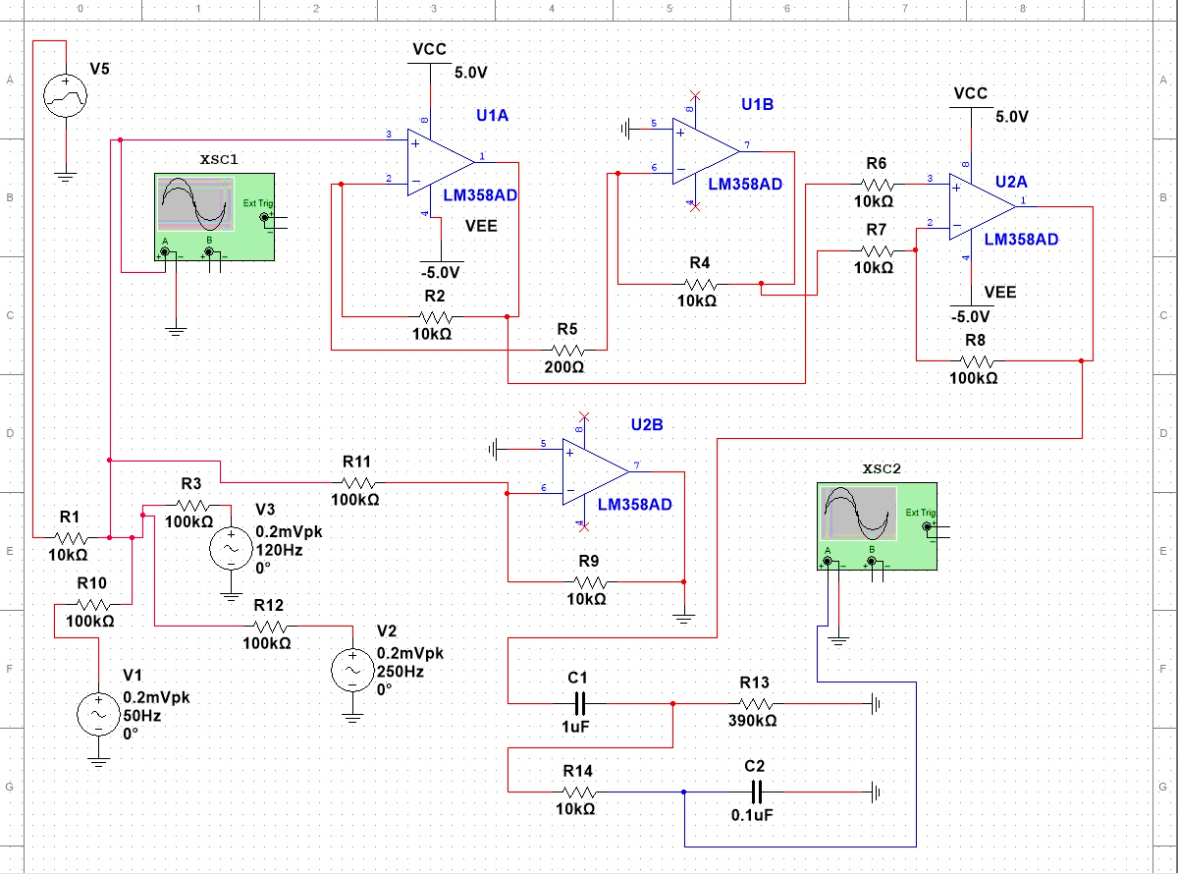

**Simulation Output:-**

